# CS 255 System Design Document Template

## UML Diagrams

### UML Use Case Diagram

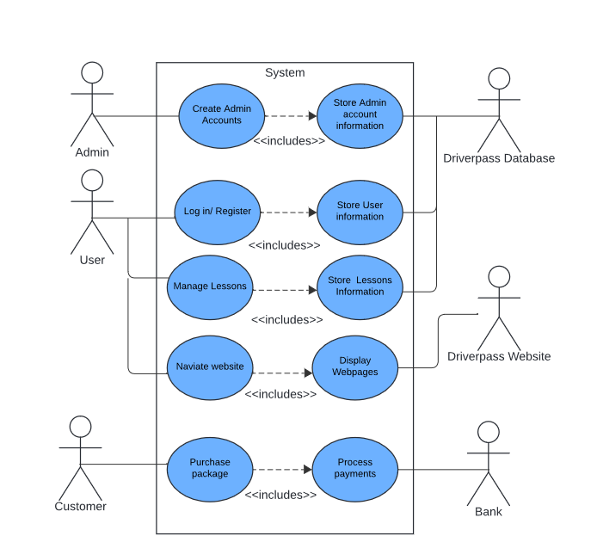

### UML Activity Diagrams

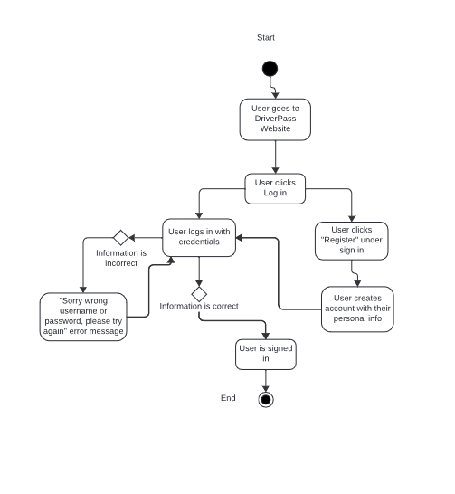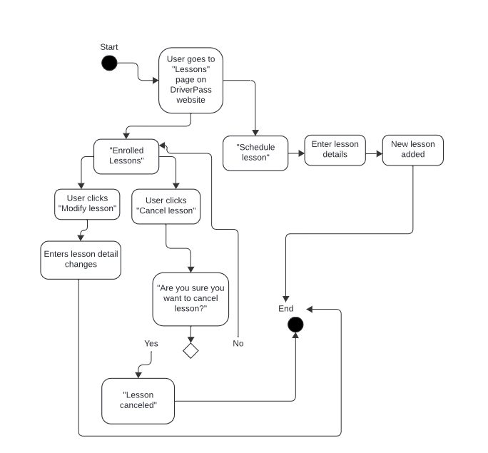

### UML Sequence Diagram

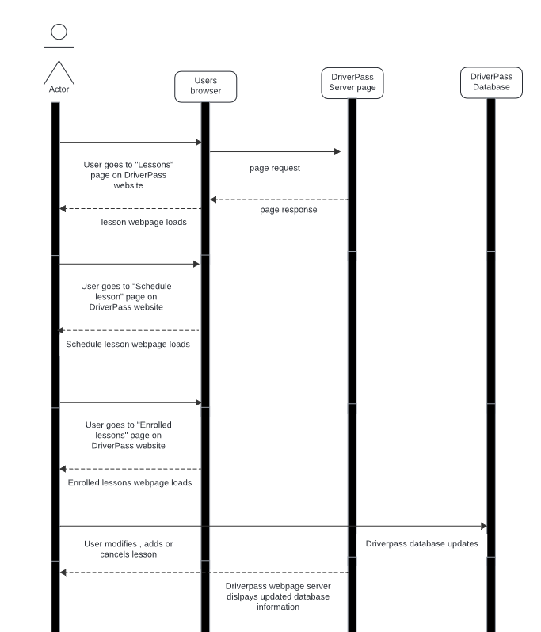

### UML Class Diagram

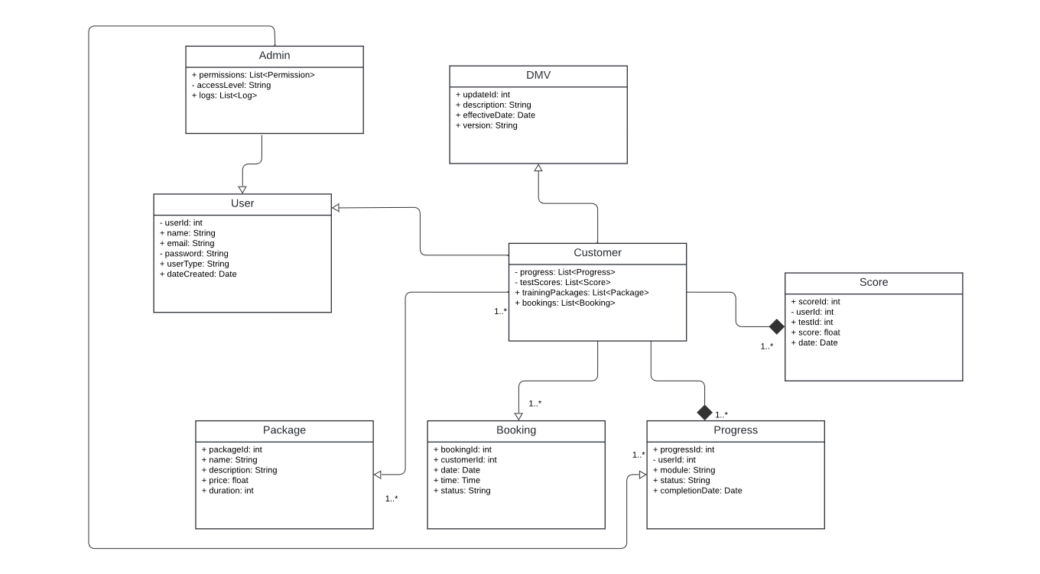

## Technical Requirements

***Hardware:***

* *dedicated server (likely running on Linux)*
* *Internet*
* *physical storage*
* *compatible computers*

***Software/tools:***

* *Windows server*
* *Web Application Framework*
* *Backend: Node.js,*
* *Frontend: “React” for a responsive user interface.*
* *IDEs like Visual Studio Code/PyCharm for software development.*
* *Version control system (Git) for source code managing.*

***infrastructure:***

* *secure authentication methods (e.g., OAuth 2.0, JWT) for user access and data security.*
* *A database like PostgreSQL or MySQL to manage user data, bookings, and reports.*